Test Case: tc002_SPX_Dev5_Crear_Requisicion_Spot_Tipo_Cobro_Project
Step 1 - Enter username and password and click to button Enter: Credentials Entered
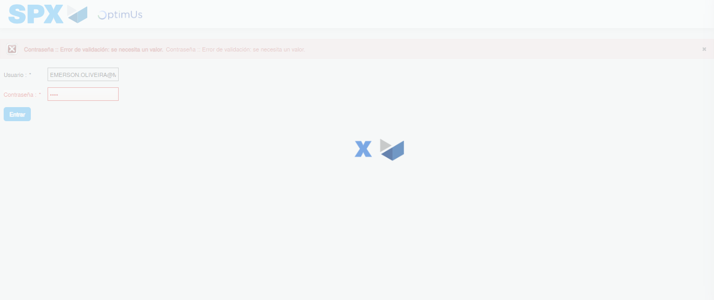Image file-name: QC_Testing-tc002_SPX_Dev5_Crear_Requisicion_Spot_Tipo_Cobro_Project-1785974488627

Step 2 - Select to UEN and Access to Spot Buy Requisitions : UEN Correctly selected and Correct access
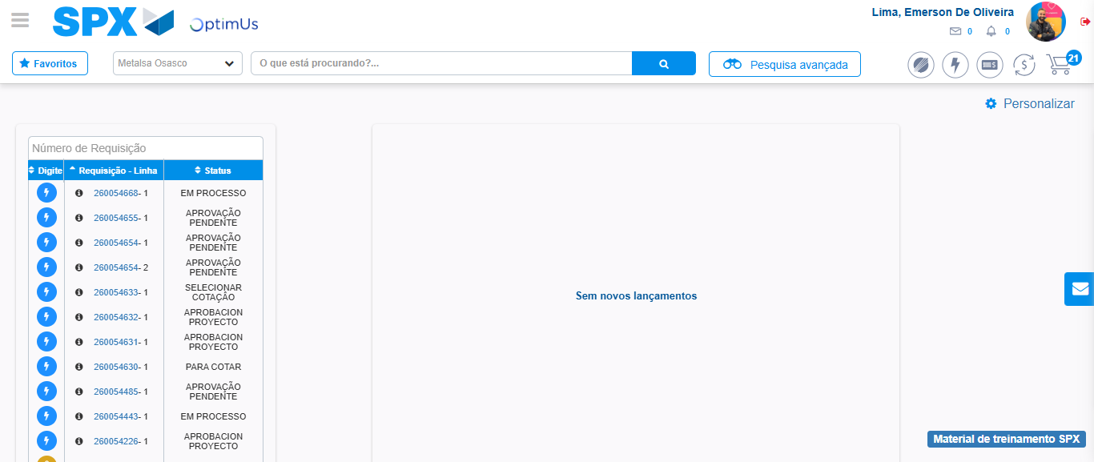Image file-name: QC_Testing-tc002_SPX_Dev5_Crear_Requisicion_Spot_Tipo_Cobro_Project-1785974514657

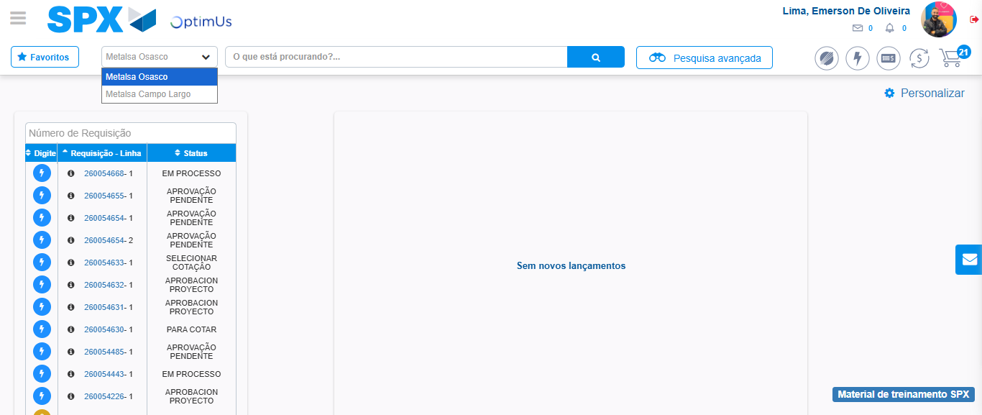Image file-name: QC_Testing-tc002_SPX_Dev5_Crear_Requisicion_Spot_Tipo_Cobro_Project-1785974517140

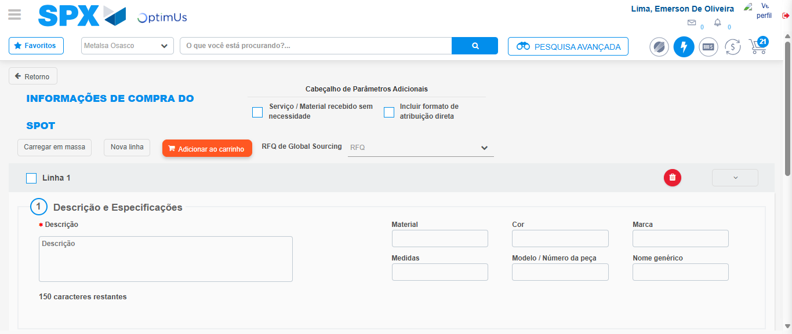Image file-name: QC_Testing-tc002_SPX_Dev5_Crear_Requisicion_Spot_Tipo_Cobro_Project-1785974521580

Step 3 - Data Capture Spot Buy Requisition: Data captured correctly
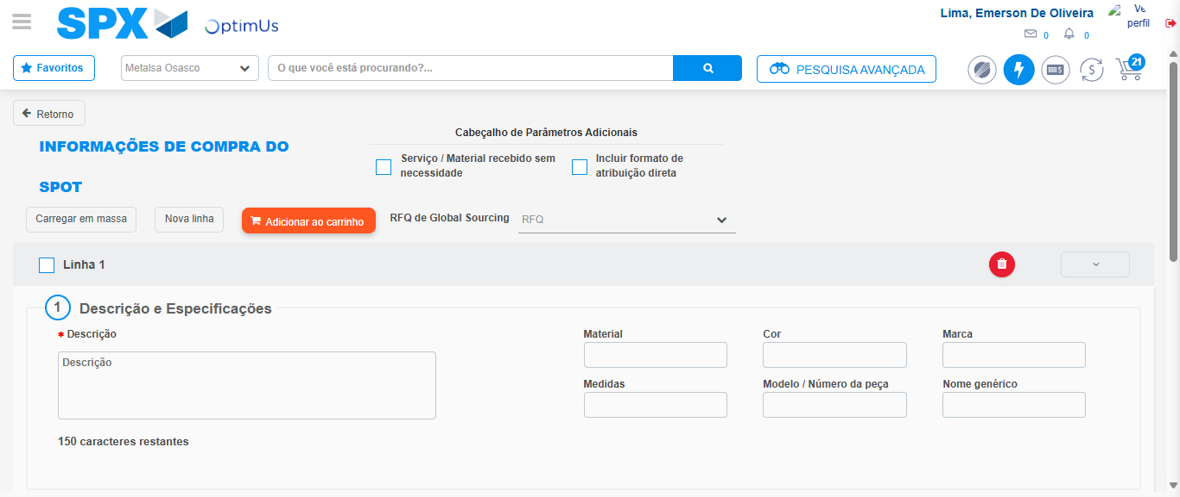Image file-name: QC_Testing-tc002_SPX_Dev5_Crear_Requisicion_Spot_Tipo_Cobro_Project-1785974521847

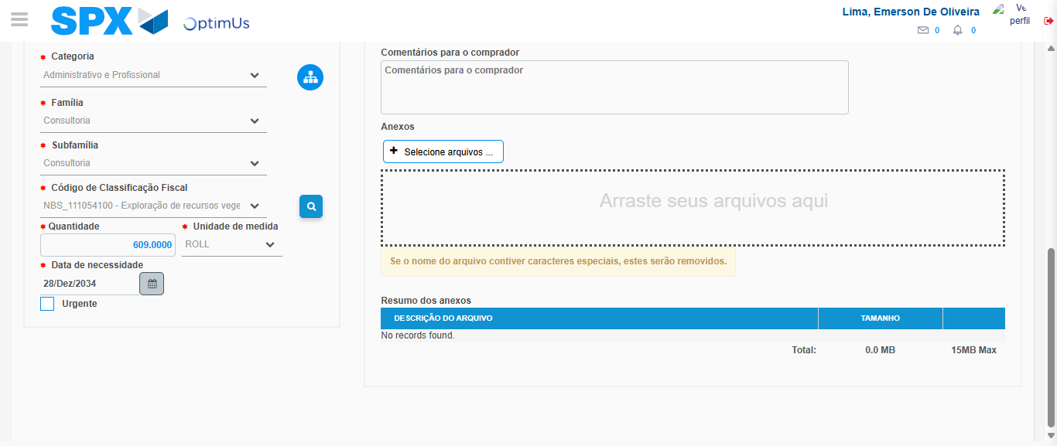Image file-name: QC_Testing-tc002_SPX_Dev5_Crear_Requisicion_Spot_Tipo_Cobro_Project-1785974537374

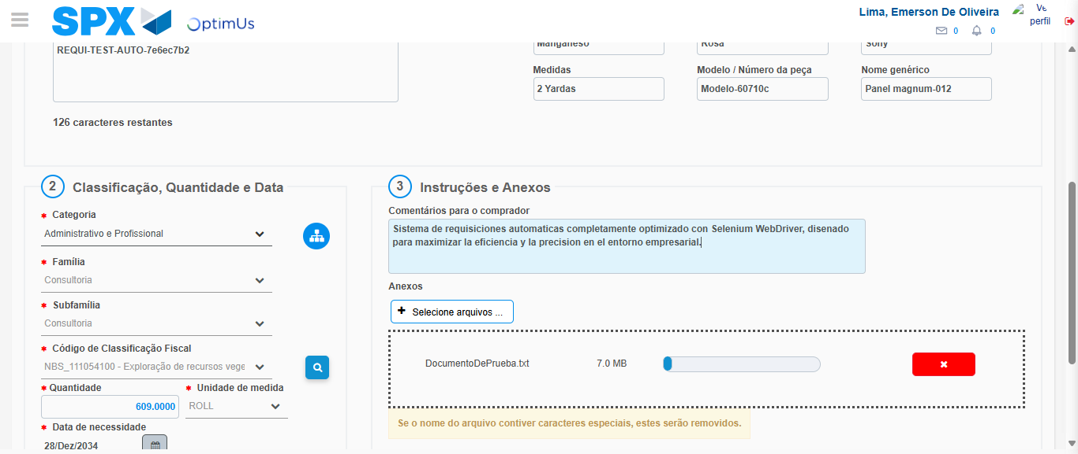Image file-name: QC_Testing-tc002_SPX_Dev5_Crear_Requisicion_Spot_Tipo_Cobro_Project-1785974538129

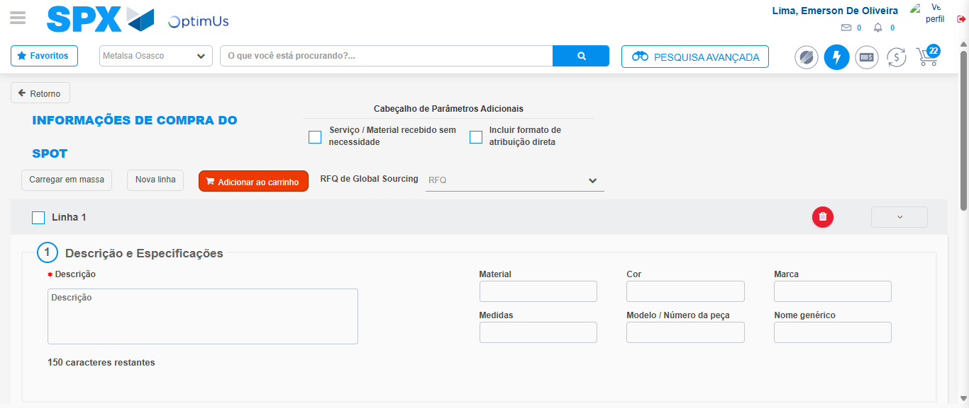Image file-name: QC_Testing-tc002_SPX_Dev5_Crear_Requisicion_Spot_Tipo_Cobro_Project-1785974542877

Step 7 - Return to Main Page SPX : Return to Main Page SPX
Image file-name: QC_Testing-tc002_SPX_Dev5_Crear_Requisicion_Spot_Tipo_Cobro_Project-1785974514657

Image file-name: QC_Testing-tc002_SPX_Dev5_Crear_Requisicion_Spot_Tipo_Cobro_Project-1785974517140

Image file-name: QC_Testing-tc002_SPX_Dev5_Crear_Requisicion_Spot_Tipo_Cobro_Project-1785974521580

Image file-name: QC_Testing-tc002_SPX_Dev5_Crear_Requisicion_Spot_Tipo_Cobro_Project-1785974545089

Image file-name: QC_Testing-tc002_SPX_Dev5_Crear_Requisicion_Spot_Tipo_Cobro_Project-1785974545217

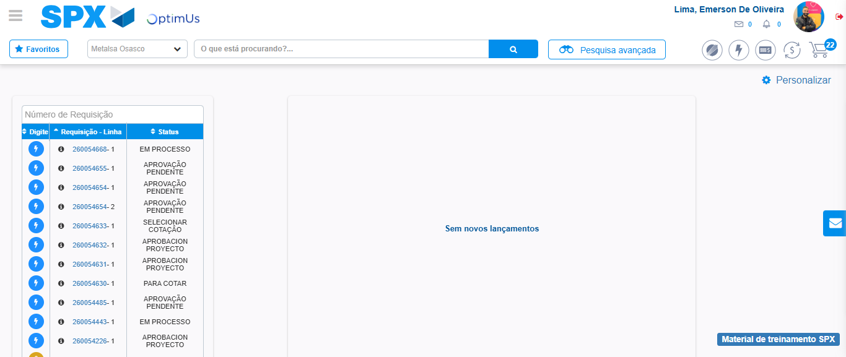Image file-name: QC_Testing-tc002_SPX_Dev5_Crear_Requisicion_Spot_Tipo_Cobro_Project-1785974566234

Step 8 - Log Out : Log Out SPX
Image file-name: QC_Testing-tc002_SPX_Dev5_Crear_Requisicion_Spot_Tipo_Cobro_Project-1785974566422

